**REPORT**

**Pet Adoption**

Course ALY6070 : **Communicate/Visual Data Analytics**

**CRN:** 80811

Term: Spring 2019 Quarter

**Team Members:**

Shraddha Thakkar

Anudeep Vemula  
Kishan Karicherla   
Mihir Thakkar  
Preeti Yerkuntwar

**Submitted to:**  Prof. Trubskyy, Mykhaylo B.

**Date:** June 30, 2019

**Business Problem:** An animal welfare shelter in Malaysia wants to promote the adoption of pets in the cities and thus wants to analyze which features significantly contribute to it. The welfare shelter has shared data of 14993 pets along with 24 attributes. They want to identify which of the 24 attributes are to be focused on so that quickness of adoption in cities across Malaysia can be increased.

**Significant features predicting the type of pet that is adopted**

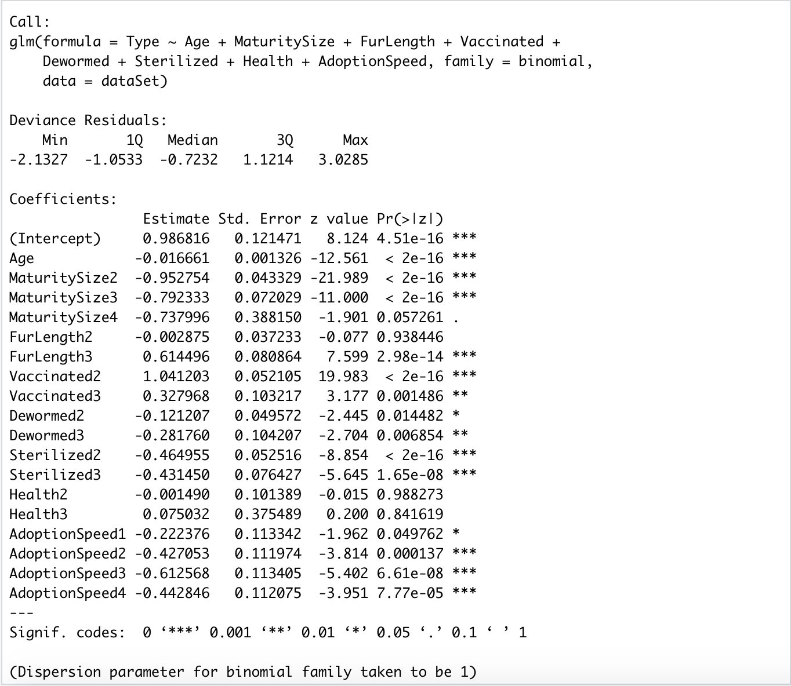

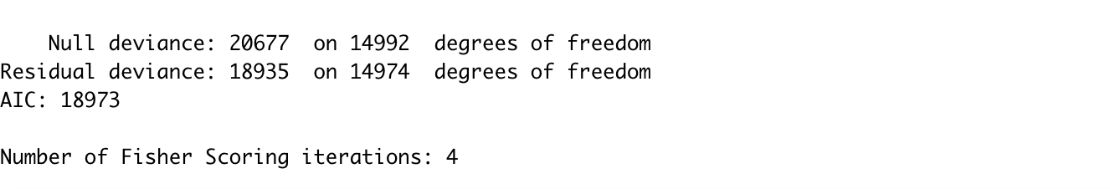

A logistic regression model gives Age, Maturity Size, Vaccinated, Dewormed, Sterilized, Adoption Speed as the important features which are able to predict whether the pet adopted is a cat or a dog. The analysis presented below explores relationship between the features and adoption speed of cats and dogs at the shelter.

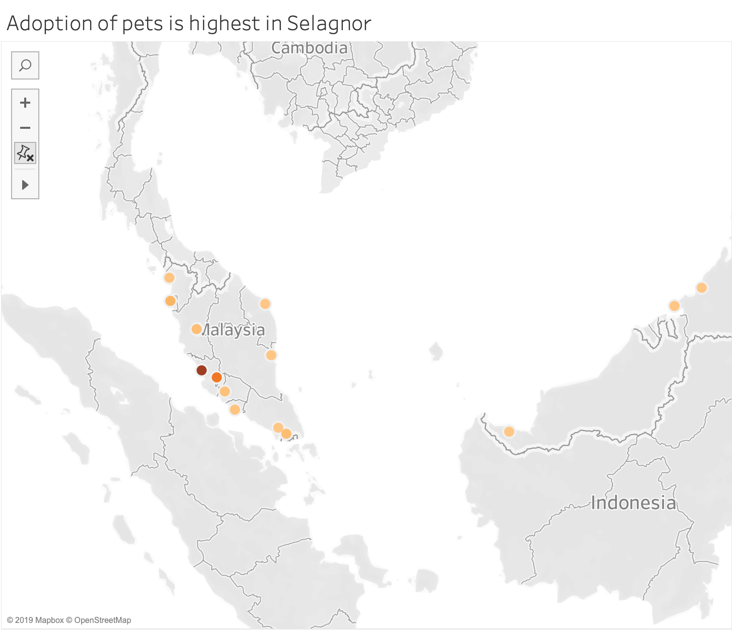

**Fig 1: Map showing the cities adopting pets in Malaysia**

Selangor tops the list when it comes to adopting pets in Malaysia. Among the top 4 other than Selangor are Kuala Lumpur, Perak, Pulau Pinang. Since many animals have adopted in these 4 cities the rest of the analysis is focused only on the top 4 cities.

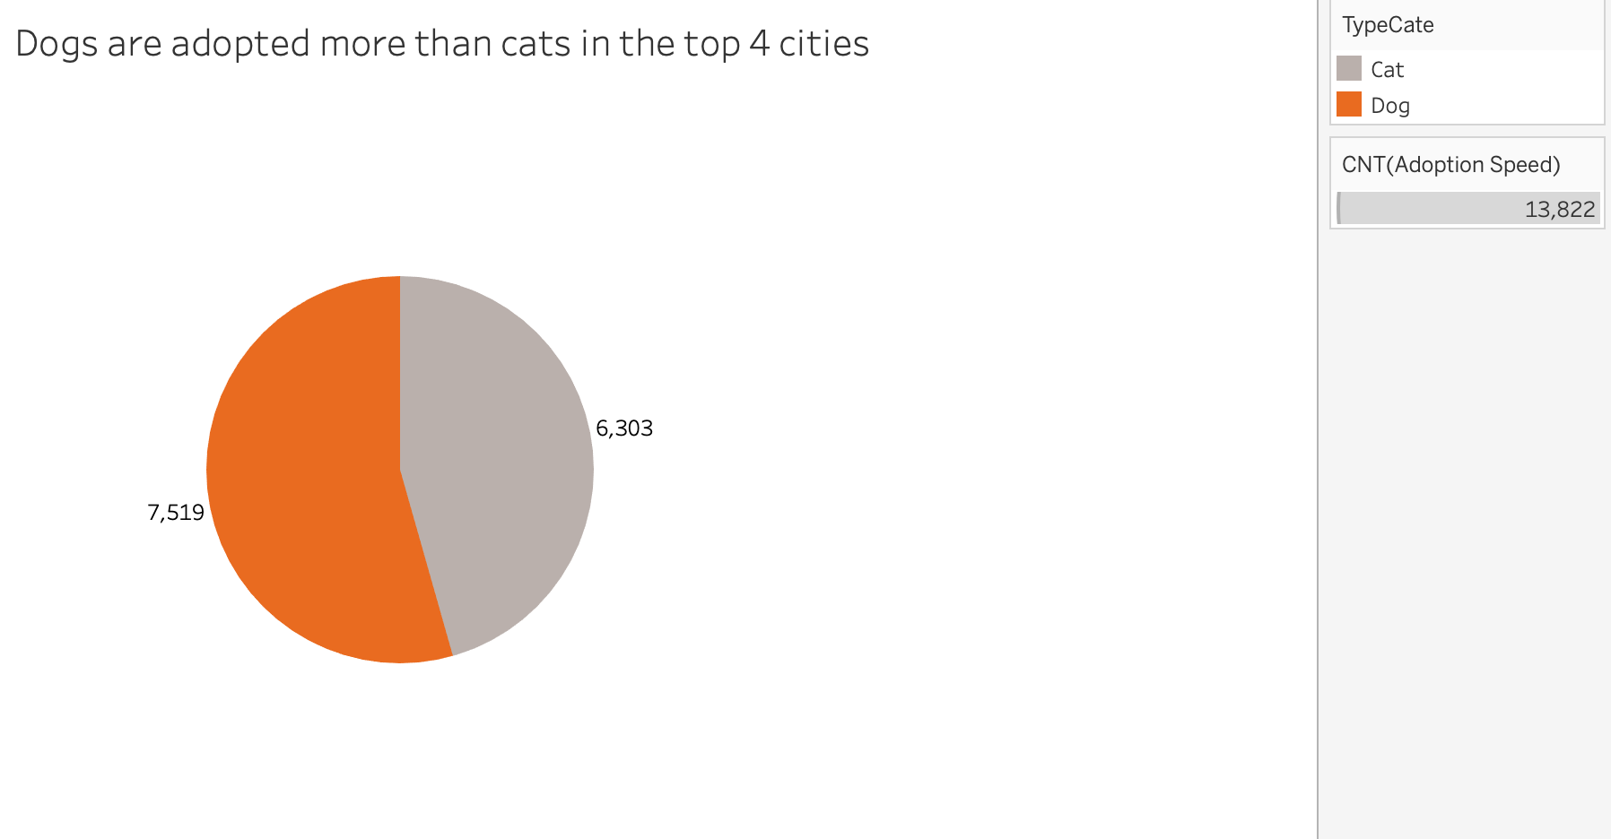

**Fig 2: Count of adoption of dogs vs cats**

Overall, dogs are adopted more than cats in the top 4 cities. However, there isn’t a huge difference between the number of dogs adopted and the number of cats adopted.

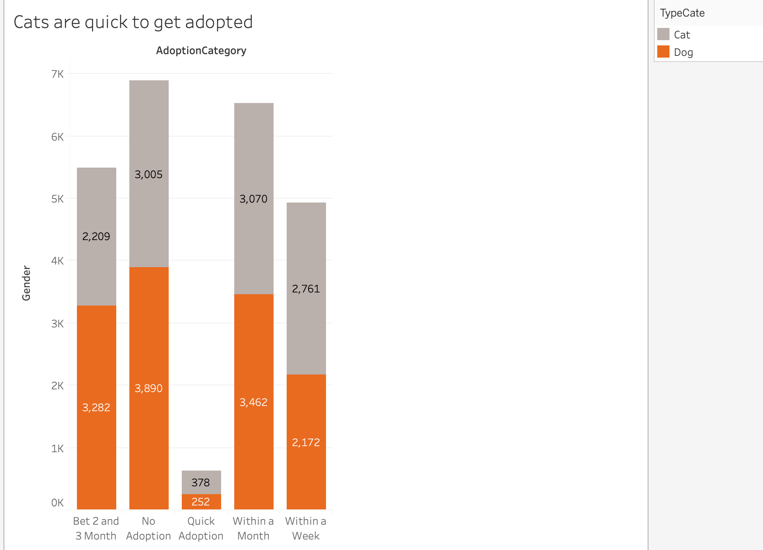

**Fig 3: Adoption speed vs type of the pet**

The quickness of adoption, however, is more among cats as shown in Fig 3. After being put up for adoption, cats are more likely to get adopted quickly than dogs. It could be said that cats are preferred animals for adoption.

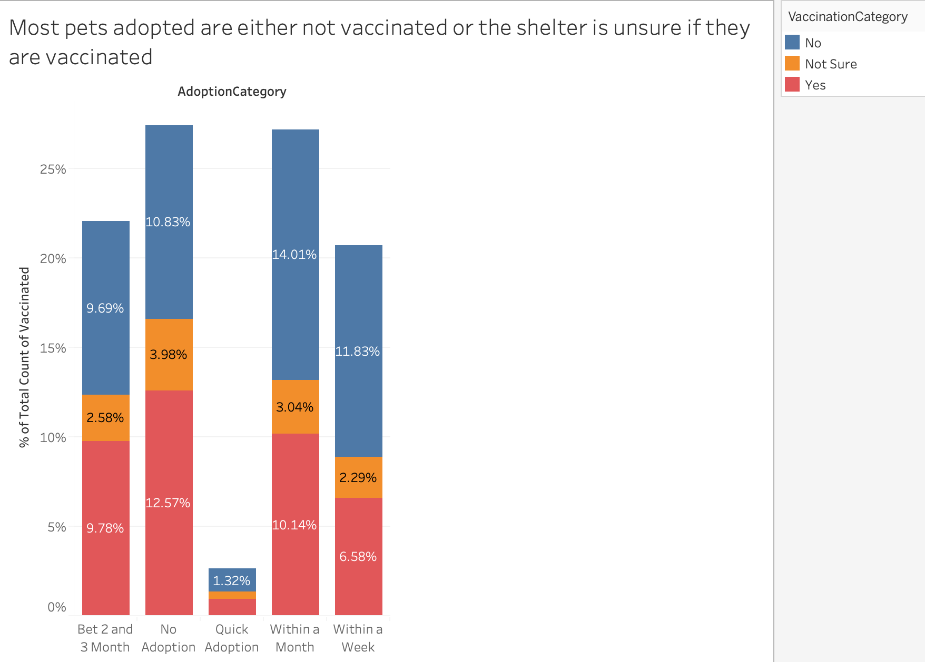

**Fig 4: Vaccination vs Adoption Speed**

As shown from Fig 4, pets that are not vaccinated or the shelter is unsure of the vaccination of the pet are more in percentage. The pet owners should be informed about the post-adoption care of the animal so that it doesn’t get infected. Better still, the animal welfare shelter should vaccinate the pets before they are put up for adoption so that any potential health risk can be avoided.

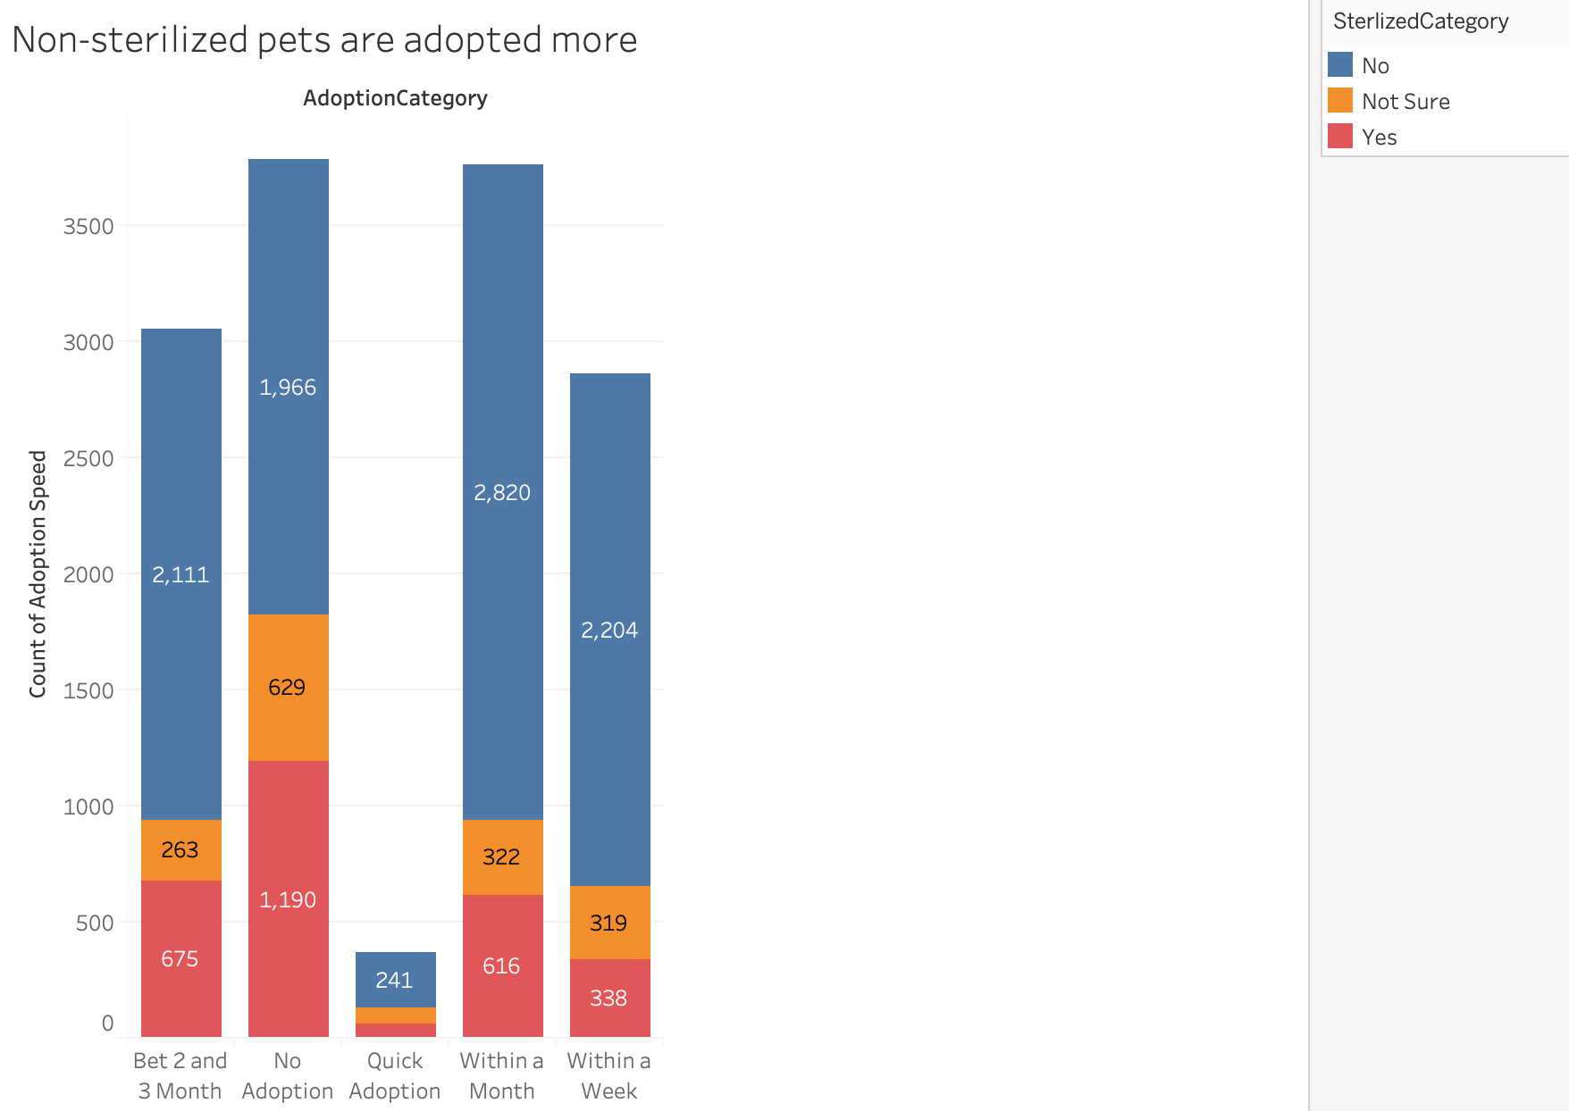

**Fig 5: Sterilization vs Adoption Speed**

Sterilized pets are not preferred as much as non-sterilized pets. This could be because many owners view sterilization as an act of cruelty against the animals.

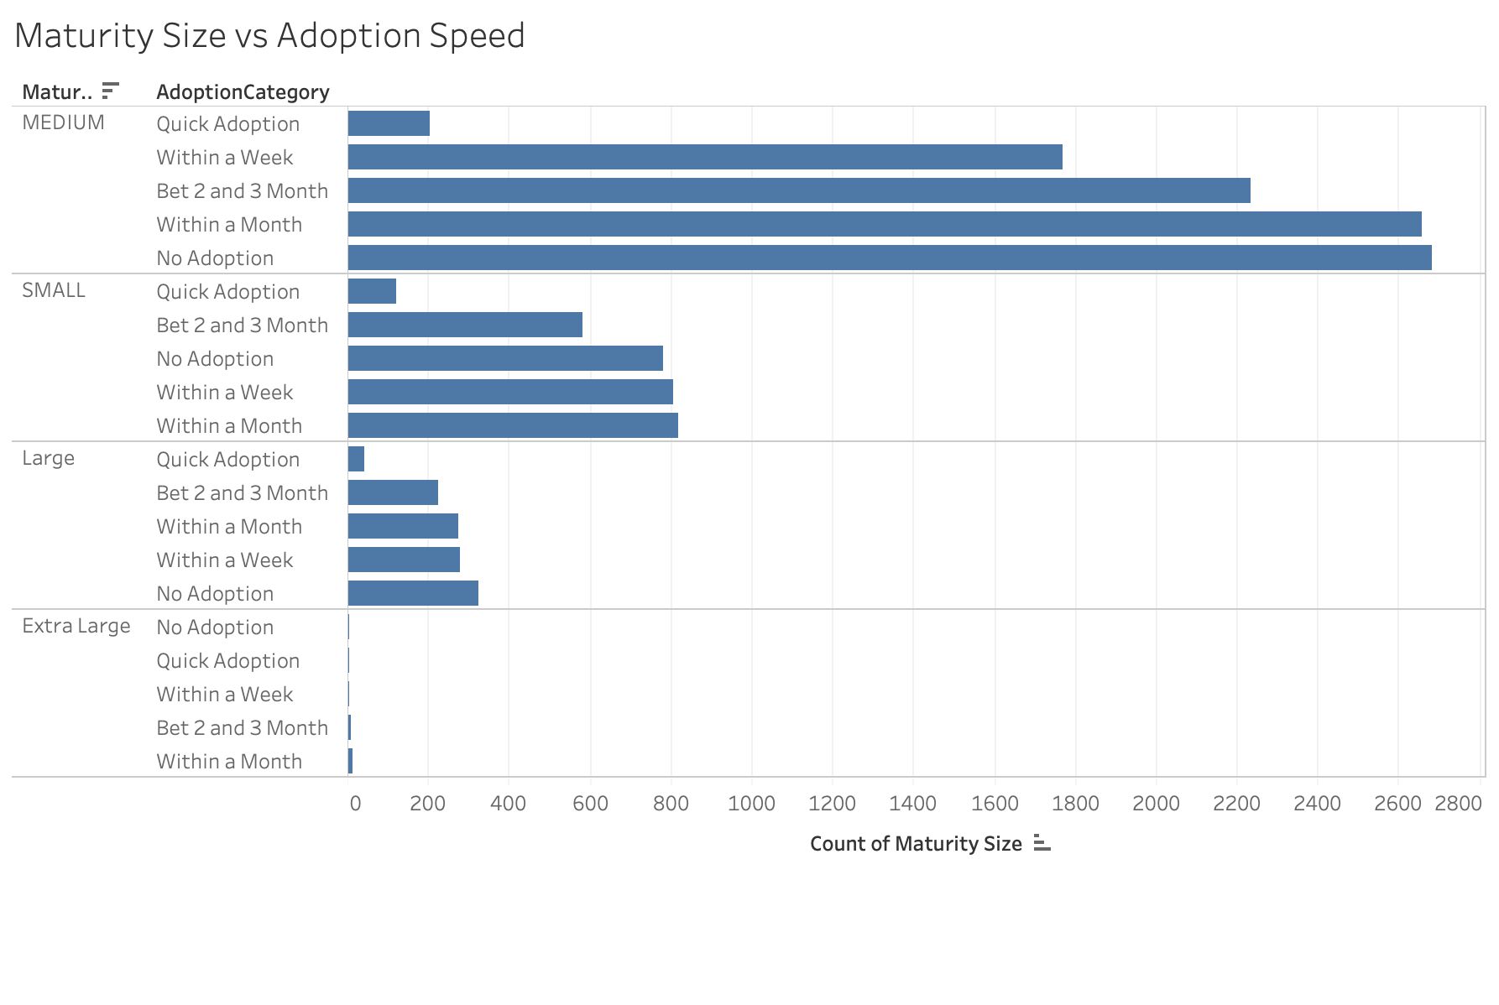

**Fig 6: Maturity Size vs Adoption Speed**

The animal shelter has more medium sized pets. However, the rate of adoption is slow amongst all the maturity sizes. With more number of pets getting adopted after a month across all the maturity sizes.

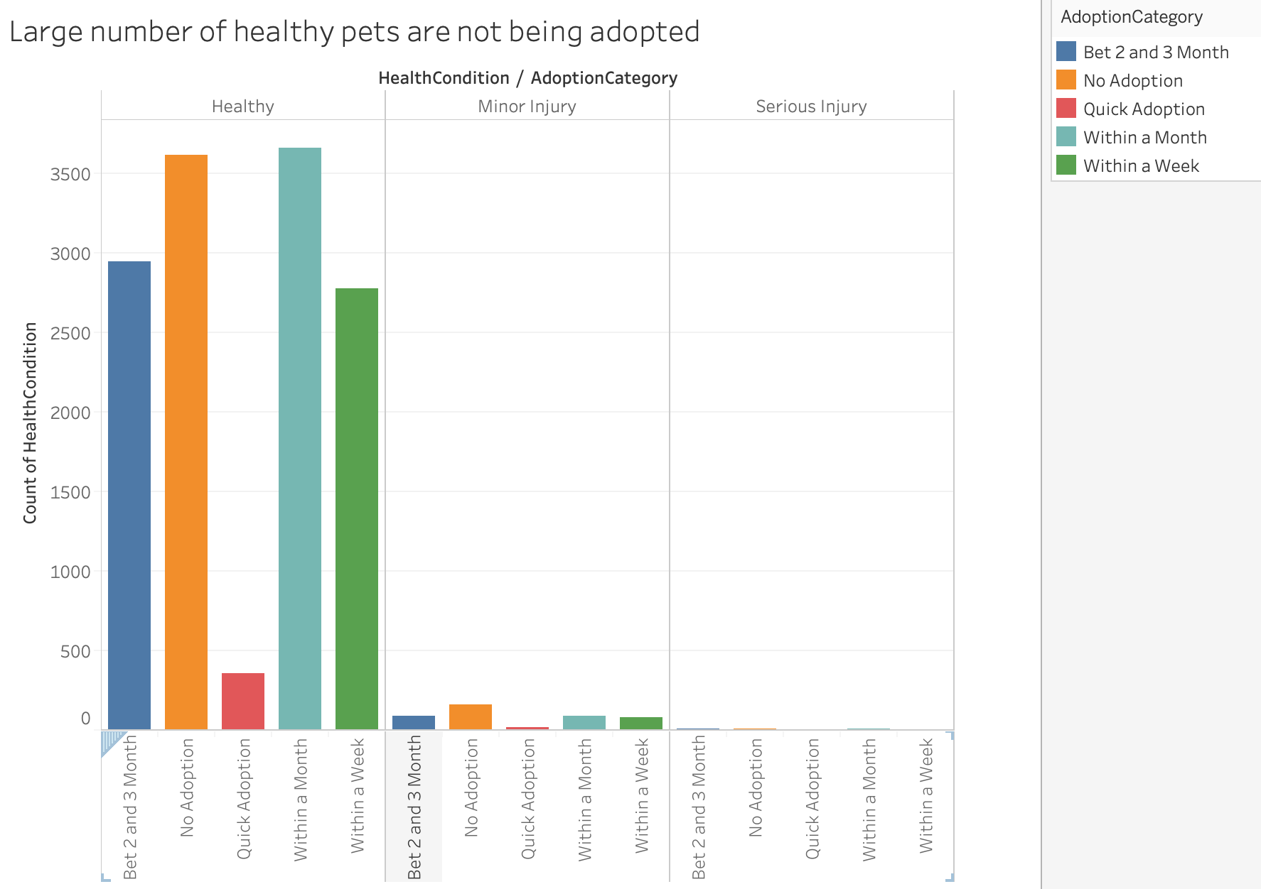

**Fig 7: Health vs Adoption Speed**

The animal welfare shelter should promote the health of animals put up for adoption as many of their healthy animals are not being adopted.

**Findings:**

1. Selangor is the topmost city in Malaysia that adopts animals
2. Dogs are adopted more than cats
3. The quickness of adoption is more among cats at the welfare shelter
4. Pet owners should be made aware of the post-adoption care about vaccinating the pet
5. Pets that are not sterilized are preferred more
6. Adoption rate is slow amongst all maturity sizes
7. The health of the pets at the animal shelter should be promoted more as they fall under the category of not being adopted.